

“Magna potestas magna cum responsabilitate venit”
With great power comes great responsibility

Table of Contents – UX/UI Design
- Introduction / Purpose……………………………………………………………………
- Design Principles & Philosophy………………………………………………………..
- User Journeys (Scenarios).......................................................................................
- Information Architecture (IA)...................................................................................
- Wireframes (Low Fidelity)........................................................................................
- UI Guidelines (High Fidelity Components).............................................................
- Accessibility & Inclusivity Standards………………………………………………….
- Interaction Patterns………………………………………………………………………..
- Prototypes (Optional)................................................................................................
- Handoff Notes to Developers…………………………………………………………….

1. Introduction / Purpose
This document defines the user experience (UX) and user interface (UI) foundations of the Magna Coders Community Application.
It translates the vision and functional requirements from previous stages into a structured visual and interaction system that ensures every feature serves real users with clarity and consistency.
The goal of this document is to:
- Establish the design philosophy and principles guiding all interface decisions.
- Describe the user journeys and interaction flows for each primary user group—developers, designers, idea owners, businesses, and mentors.
- Present the information architecture that connects all parts of the application (Profiles, Skill Directory, Collaboration Hub, Opportunities Board, etc.).
- Provide wireframe and UI component references that define the look, feel, and usability of the system.
- Act as a handoff guide between design and development teams, ensuring that what’s designed is feasible, consistent, and accessible.
This stage exists to bridge intent and implementation—turning written requirements into tangible experiences that users can intuitively navigate.
A coherent UX/UI foundation prevents misinterpretation of functionality, reduces rework during development, and ensures that the Magna Coders platform embodies its core mission:
“To create a living ecosystem where skills meet purpose through seamless, human-centered design.”

2. Design Principles & Philosophy
The UX/UI design of Magna Coders is guided by the belief that technology should amplify human collaboration, not complicate it. Every interface, button, and layout choice must reduce friction and foster meaningful interaction between creators, collaborators, and organizations.

2.1 Design Philosophy
- Human-Centered Design
The user’s mental model is the starting point. Interfaces should speak the user’s language — not technical jargon. Each screen answers one clear question: “What can I do next?”
- Simplicity as Power
Complexity repels contribution. Simplicity invites participation. Every component should perform a clear purpose with minimal cognitive load. The design must feel inviting, not intimidating.
- Transparency & Trust
Users must always know where they are, what’s happening, and what their actions trigger. Visibility builds trust; hidden logic erodes it.
- Consistency Over Creativity
Consistency accelerates learning. Buttons, colors, and patterns should behave uniformly across the app. Creativity is welcome in expression — not in function.
- Community at the Core
The app is not an individual’s portfolio — it’s a collective ecosystem. UI decisions should always encourage connection: “Can I collaborate with this person?” “Can I add value here?”
- Inclusivity & Accessibility
Accessibility is not optional. Text contrast, color balance, mobile responsiveness, and screen-reader support must be considered from the first wireframe, not the final polish.
- Feedback Loops Everywhere
Every user action must produce feedback — visual (color change, animation), textual (confirmation), or auditory (ping). Silence equals confusion.
- Local Familiarity, Global Usability
The design should reflect a Kenyan sense of community while maintaining international standards. Use familiar naming, cultural imagery, and local city references (Nairobi, Mombasa, Kisumu) without compromising global appeal.

2.2 Core Design Goals
- Reduce friction: users reach their goals with fewer clicks and decisions.
- Encourage exploration: the app rewards curiosity — users feel safe to navigate.
- Support quick recognition: icons and layouts should instantly communicate function.
- Empower creation: users feel capable of starting or joining projects within minutes.

2.3 Guiding Visual Tone
- Color palette: calm, neutral base (light grays, whites) with vibrant accent colors representing collaboration (blues, greens, or teals).
- Typography: modern sans-serif (e.g., Inter, Poppins, or Open Sans) for clarity and legibility.
- Iconography: minimal, line-based icons for consistency and quick recognition.
- Layout style: grid-based, with generous white space for focus and readability.
Design Intent:
“Every interaction within Magna Coders should feel like stepping into a well-organized workspace — clean, calm, and built for collaboration.”

3. User Journeys (Scenarios)

Purpose of This Section
User journeys describe how different user types move through the Magna Coders app to achieve their goals.
They help designers and developers understand context, motivation, and friction points so the interface can anticipate needs instead of merely reacting to clicks.
Each journey below follows a simple rhythm:
Trigger → Goal → Steps → Emotions → Opportunities for Design.

3.1 Journey A: The Developer / Designer – Joining and Collaborating
Trigger:
A developer hears about Magna Coders through social media and wants to join to find collaborators.
Goal:
Showcase skills, join an active project, and gain portfolio visibility.
Steps:
- Lands on home page → chooses “Join Community.”
- Registers via email or OAuth.
- Completes profile: name, bio, skills, portfolio links, availability.
- Browses Mini-Project Invitations and Opportunities Board.
- Applies to join a project → receives confirmation.
- Contributes via Collaboration Hub (chat, GitHub sync).
- Gets recognition on leaderboard after contribution is verified.
Emotions:
Curiosity → Excitement → Satisfaction → Pride.
Opportunities for Design:
- Onboarding checklist to show progress (reduces overwhelm).
- Smart suggestions: “Projects that match your skill set.”
- Visual celebration after first accepted contribution.

3.2 Journey B: The Idea Owner – Starting a Mini-Project Invitation
Trigger:
A user has an idea (e.g., a civic-tech tool) and needs a small team.
Goal:
Post a mini-project and attract collaborators with the right skills.
Steps:
- Signs in → clicks “Start a Project.”
- Fills form: title, description, required skills, target impact, and location.
- Posts invitation → system promotes it on the Collaboration Hub.
- Receives join requests → reviews profiles → approves team members.
- Creates a shared GitHub repo → manages progress via hub updates.
- Marks project as “Complete” → team gets recognition.
Emotions:
Hope → Anticipation → Relief → Empowerment.
Opportunities for Design:
- Templates for quick project posting.
- Dashboard for tracking join requests.
- Visual team roster with avatars + roles.
- Auto-badge “Project Creator” for profile credibility.

3.3 Journey C: The Business / Organization – Posting an Opportunity
Trigger:
An NGO or company seeks a team to solve a technical challenge.
Goal:
Find verified, collaborative talent without corporate complexity.
Steps:
- Registers as “Business Account.”
- Creates an Opportunity Post with project goals, deadlines, and required skills.
- Receives proposals or team applications from members.
- Reviews profiles → selects a team.
- Tracks progress through updates on the hub.
- Provides feedback + testimonial after delivery.
Emotions:
Skepticism → Trust → Confidence → Loyalty.
Opportunities for Design:
- Guided posting wizard with examples.
- Auto-suggested member matches based on skill tags.
- Visual tracker for collaboration progress.
- “Verified Business” badge for credibility.

3.4 Journey D: The Community Mentor – Guiding and Recognizing Others
Trigger:
An experienced developer or advisor joins to mentor new contributors.
Goal:
Support active projects and help newcomers grow.
Steps:
- Creates a mentor profile with areas of expertise.
- Browses active mini-projects → joins as mentor.
- Offers feedback in comment or chat sections.
- Flags impactful projects for community recognition.
- Gains mentor badges and reputation points.
Emotions:
Pride → Engagement → Fulfillment.
Opportunities for Design:
- “Mentor View” with ongoing projects seeking guidance.
- Badges for consistent mentorship.
- Highlight mentors on the community page.

3.5 Journey E: The Local Connector – Finding Peers Nearby
Trigger:
A user wants to collaborate with people in their own city.
Goal:
Discover nearby developers/designers and join location-based projects.
Steps:
- Opens Local Discovery tab.
- Filters by city → sees nearby members and projects.
- Sends collaboration requests or starts a local mini-project.
- Attends local community events (future feature).
Emotions:
Curiosity → Belonging → Excitement.
Opportunities for Design:
- Map view or city-based list of members.
- City badges (“Nairobi Contributor”).
- Filters that combine location + skill tags.

3.6 Summary of Journey Insights
User Type | Primary Motivation | Key Design Need
Developer / Designer | Visibility & collaboration | Smooth onboarding + smart matching
Idea Owner | Building a team | Easy project posting + control dashboard
Business / Organization | Access to talent | Simple posting flow + credibility markers
Mentor | Impact & guidance | Dedicated mentor view + recognition
Local Connector | Community belonging | Map interface + localized filters

Design Intent:
“Each user journey is a promise: the app meets you where you are — and guides you, step by step, to where collaboration begins.”

4. Information Architecture (IA)

4.1 Purpose of This Section
Information Architecture (IA) organizes the app’s content and functionality so users can intuitively find what they need.
It defines the hierarchical structure, navigation logic, and content relationships that make the user experience simple, consistent, and scalable as the community grows.
IA ensures that Magna Coders feels like one unified ecosystem, not a collection of disconnected features.

4.2 Core Navigation Map

Top-Level Sections
- Home / Dashboard
  - Overview of community activity, trending projects, and active opportunities.
  - Quick access to create or join projects.
- Profiles
  - Personal user profiles (name, bio, skills, portfolio, location, availability).
  - Edit and privacy settings.
  - Public profile view for others to explore.
- Skill Directory
  - Search and filter members by skill, experience, or location.
  - List and card view options.
  - Quick action: “Invite to Project.”
- Collaboration Hub
  - Active project spaces (chat, GitHub sync, progress updates).
  - Project overview → members → tasks → discussions → files.
  - Visibility toggles (private/public projects).
- Opportunities Board
  - Businesses and organizations post tech challenges or roles.
  - Filters by category, skills needed, and duration.
  - Application and review workflows.
- Mini-Project Invitations
  - User-generated projects and team invites.
  - Post → Approve requests → Manage collaborators.
  - “Featured projects” section for visibility.
- Community Recognition
  - Leaderboards, badges, and success stories.
  - Spotlight on top contributors and completed projects.
- Local Discovery
  - City-based directory (e.g., Nairobi, Mombasa, Kisumu).
  - Map or list view of nearby members and projects.
  - Future extension: event listings.
- Settings & Support
  - Account, notifications, privacy.
  - FAQs, feedback, and customer support channel.

4.3 Navigation Flow (Simplified Sitemap)

Dashboard
│
├── Left_Panel (Navigation & Identity)
│ ├── Profile
│ │ ├── View_Profile
│ │ ├── Edit_Profile
│ │ └── Status (Online / Offline)
│ │
│ ├── Main_Navigation
│ │ ├── Dashboard (Home)
│ │ ├── Members (Skill Directory)
│ │ │ ├── Browse_All
│ │ │ ├── Filter_By_Skill
│ │ │ └── Filter_By_Location
│ │ ├── Projects
│ │ │ ├── My_Projects
│ │ │ ├── All_Projects
│ │ │ └── Create_Project
│ │ ├── Chats
│ │ │ ├── Direct_Messages
│ │ │ └── Project_Channels
│ │ ├── Local_Discovery
│ │ │ ├── City_Filter
│ │ │ └── Map_View
│ │ ├── Recognition (Community)
│ │ │ ├── Leaderboard
│ │ │ └── Highlights
│ │ └── Settings
│ │ ├── Account
│ │ ├── Notifications
│ │ └── Privacy
│ │
│ ├── Quick_Actions
│ │ ├── Create_Project
│ │ ├── Find_Collaborators
│ │ └── Post_Update
│ │
│ └── Shortcuts
│ ├── Mentorship
│ ├── Resources
│ └── Help_Center
│
├── Center_Panel (Main_Feed_And_Actions)
│ ├── Welcome_Header
│ │ ├── Greeting_Message
│ │ ├── Profile_Stats (Projects, Connections, Skills)
│ │ └── Progress_Bar (Profile_Completion)
│ │
│ ├── Composer_Section
│ │ ├── Input_Field ("What are you building today?")
│ │ └── Post_Types
│ │ ├── Reel_Post
│ │ ├── Photo_Post
│ │ ├── Project_Post
│ │ └── Business_Opportunity_Post
│ │
│ ├── Feed_Stream
│ │ ├── Filters (All, Reels, Projects, Opportunities, Designs)
│ │ ├── Sort_By (Recent, Trending, Local, Network)
│ │ ├── Feed_Items
│ │ │ ├── Demo_Reel
│ │ │ ├── Project_Invitation
│ │ │ ├── Design_Drop
│ │ │ ├── Business_Opportunity
│ │ │ └── Text_Update
│ │ └── Engagement_Actions (Like, Comment, Join, Apply)
│ │
│ └── Quick_Insights
│ ├── New_Projects_This_Week
│ ├── Top_Contributors
│ └── New_Business_Posts
│
└── Right_Panel (Context_Awareness)
├── Invitations_And_Requests
│ ├── Collaboration_Invites
│ ├── Join_Requests
│ └── Business_Inquiries
│
├── Trending_Now
│ ├── Reels
│ ├── Projects
│ ├── Businesses
│ └── Design_Drops
│
├── Stats_And_Achievements
│ ├── Projects_Active_Completed
│ ├── Skills_Summary
│ └── Badges (Contributor, Mentor, Project_Lead)
│
├── Active_Members
│ ├── Online_List
│ └── Invite_To_Project
│
└── Upcoming_Events
├── Community_Meetups
├── Hackathons
└── Workshops

5. Wireframes (Low-Fidelity Overview)

5.1 Purpose of This Section
Wireframes serve as the visual blueprint for the Magna Coders interface.
They define the placement, hierarchy, and relationship between elements before any color, iconography, or visual style is applied.
The goal:
To validate usability and flow before visual polish.

5.2 Dashboard Overview (Tri-Panel Structure)
---------------------------------------------------------
| LEFT PANEL | CENTER PANEL (MAIN FEED) | RIGHT PANEL |
---------------------------------------------------------

Each panel has a clear psychological role:
- Left → Control: Identity & navigation.
- Center → Creation: Interaction and community feed.
- Right → Awareness: Real-time context and recognition.

A. LEFT PANEL – Navigation & Identity
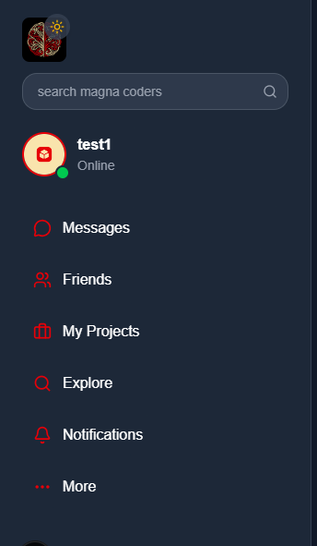
UX Purpose:
Acts as a fixed anchor — users always know where they are.
Each label uses clear iconography for fast scanning.

B. CENTER PANEL – Main Feed & Actions

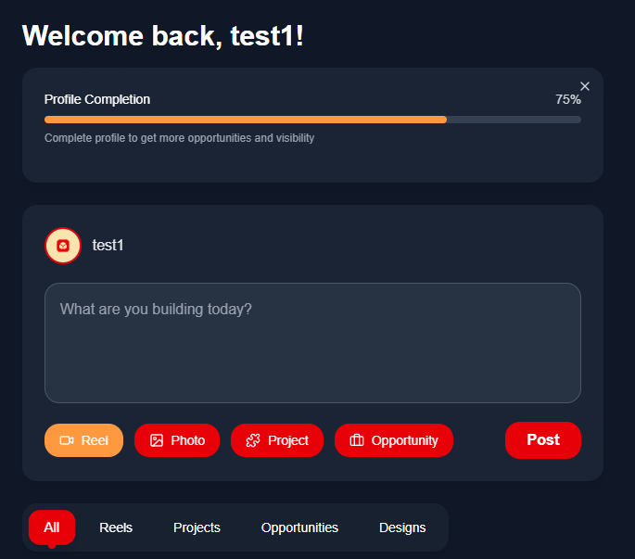
UX Purpose:
A hybrid of content and collaboration — encourages creation as much as consumption.
Users can post, join, or react without leaving the dashboard.

C. RIGHT PANEL – Context, Trends & Awareness
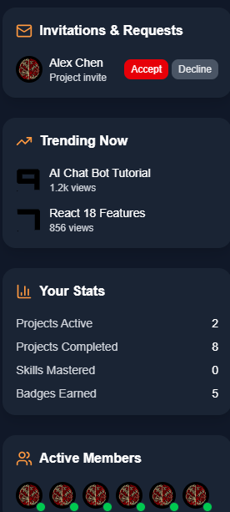

UX Purpose:
Drives ongoing engagement — keeps the user aware of social proof, new chances, and real-time momentum.

5.3 Interaction Flow (Wireframe Logic)
Action | Result
Click “Create Project” (left or top CTA) | Opens modal → project creation form.
Upload Reel / Photo | Auto-classified in feed as media post.
“Join Project” | Adds user to Collaboration Hub → project chat & repo link.
“Apply Now” (Business Post) | Opens application modal → submit portfolio.
“View Member” | Opens mini profile overlay.
“Post Update” | Opens composer → quick text/image share.

5.4 Mobile Responsiveness
- Left Panel collapses → hamburger menu.
- Right Panel converts → bottom “Activity” tab.
- Center Feed → vertical scroll focus; “+ Create” FAB at bottom right.
- All CTAs adapt to one-hand thumb reach zones.

5.5 Design Notes for Handoff
- Keep consistent grid spacing (8-pt system).
- Wireframes built for 1440px desktop, scaling down to 375px mobile.
- Icons from Lucide / Feather family for clarity.
- Use neutral color placeholders (#F5F5F5 backgrounds, #333 text).

6. UI Guidelines (High-Fidelity Components)

6.1 Purpose of This Section
This chapter defines the visual and interactive system for the Magna Coders app.
It ensures every page, button, and card adheres to a consistent identity — regardless of who designs or codes it.
The UI guidelines act as a bridge between designers and developers, providing a single visual truth for the entire ecosystem.

6.2 Color System
Usage | Color | Hex Code | Psychological Purpose
Primary Background | Cream | #F9E4A D | Warm, creative base that feels collaborative and human.
Primary Accent | Red | #E70008 | Energy, action, motivation — used for CTAs and highlights.
Secondary Accent | Orange | #FF9940 | Optimism, innovation, and contrast; balances red’s intensity.
Text / Body | Black | #000000 | High contrast for readability.
Card Background | White / Light Cream | #FFF9E9 | Adds depth without breaking visual consistency.
Neutral Lines / Dividers | Gray | #E0E0E0 | Soft structural separation.
Success / Active | Green | #27AE60 | Online status or successful actions.
Error / Warning | Dark Red | #B00020 | Alerts and validation messages.
Design Rationale:
Warm colors (cream, orange, red) make the app feel alive and community-driven.
Black anchors the design, while white/cream cards maintain openness and readability.

6.3 Typography System
Type | Font Family | Weight | Example Usage
Display / Titles | Poppins | 600–700 | Section headers, dashboard titles
Subheadings | Inter | 500–600 | Card titles, panel headers
Body Text | Inter | 400 | Feed text, instructions
Buttons / Labels | Poppins | 500 | Action buttons, tabs
Caption / Metadata | Inter | 300–400 | Time stamps, small labels

Font Scale (Desktop Baseline 16px)
Type | Size | Line Height
H1 | 32px | 40px
H2 | 24px | 32px
H3 | 20px | 28px
Body | 16px | 24px
Caption | 13px | 20px
Button Text | 15px | 22px
Design Rationale:
Rounded sans-serifs (Poppins, Inter) mirror the friendliness and structure of the community brand — readable, modern, and approachable.

6.4 Spacing & Layout Grid
Element | Padding | Margin | Notes
Global Grid | 8px base spacing | 8px multiples | Maintain rhythm across all components.
Card Padding | 16px–24px | 16px | For balance and hierarchy.
Section Margin | 32px | 32px | Between primary UI sections.
Panel Gap (Left/Center/Right) | 24px | — | Breathing room for the tri-panel layout.
Layout Grid:
- Desktop: 12-column, 1440px width max.
- Mobile: 4-column, 375px width baseline.

6.5 Buttons
Type | Background | Text Color | Hover | Radius | Example Usage
Primary | #E70008 | White | Darker red (#B50006) | 12px | “Create Project”, “Join Team”
Secondary | Transparent | #E70008 | Background = #FFF2F0 | 12px | “Find Collaborators”, “Post Update”
Accent | #FF9940 | Black | Lighter orange (#FFC166) | 12px | “Apply Now”, “Invite”
Disabled | #E0E0E0 | #9E9E9E | — | 12px | Disabled actions
Microinteraction Rule:
Every button click should produce a 0.2s scale-up animation and color feedback (hover or press).

6.6 Cards & Components

Card Anatomy
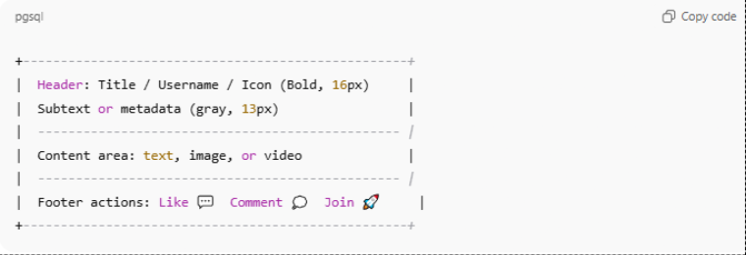

Card Type | Accent | Interaction
Reel / Demo Card | Orange bar top | Video autoplay on hover.
Project Card | Red left border | Hover shadow grows + “Join Project” button.
Design Post Card | Black icon header | Image expands on click.
Business Card | Orange footer | “Apply Now” button with subtle pulse.
Shadow: 0px 4px 12px rgba(0,0,0,0.08)
Border Radius: 16px (consistent across UI).

6.7 Iconography
Purpose | Style | Color | Size
Navigation | Line Icons | #E70008 | 20–24px
Actions (Post, Join, Apply) | Filled Icons | #FF9940 | 18px
Status Indicators | Solid Dots | Green / Red | 10px
Informational | Outline | Black | 18–20px
Source Recommendation:
Use Lucide Icons or Feather Icons (lightweight, modern, scalable SVGs).

6.8 Form Inputs
Type | Background | Border | Focus State | Radius | Placeholder Color
Text / Input Field | White | #E0E0E0 | Border red (#E70008) | 12px | #9E9E9E
Textarea | White | #E0E0E0 | Border orange (#FF9940) | 12px | #9E9E9E
Dropdown | White | #E0E0E0 | Shadow highlight | 12px | #9E9E9E
Button within Form | Red | White | Darker red hover | 12px | —

6.9 Alerts, Toasts & Feedback
Type | Background | Text | Icon | Duration
Success | #27AE60 | White | ✅ | 3s
Error | #E70008 | White | ⚠️ | 5s
Info | #FF9940 | Black | ℹ️ | 4s
Guideline:
Notifications must never cover the main feed — use corner or top-right stacking with soft slide-in motion.

6.10 Animation Guidelines
Element | Animation | Duration | Easing
Button Click | Scale 1.05x → 1x | 0.2s | ease-out
Card Hover | Shadow + translateY(-4px) | 0.3s | ease-in-out
Modal Open | Fade + scale from center | 0.25s | cubic-bezier(0.19,1,0.22,1)
Tab Switch | Slide transition | 0.3s | ease-out
All animations should feel organic — quick feedback, not dramatic transitions.

Design Intent:
“Magna Coders’ UI must feel like the digital version of a creative coworking studio — warm, clear, and alive. Every component, color, and motion should subtly say: collaboration lives here.”

7. Accessibility & Inclusivity Standards

7.1 Purpose of This Section
Accessibility is not an afterthought — it’s a design value.
It ensures the platform welcomes all users regardless of ability, neurotype, or environment.
This chapter aligns Magna Coders with WCAG 2.1 AA standards and inclusive design principles.
Intent: “If someone can contribute value, the interface should never be what excludes them.”

7.2 Core Principles
Principle | Guideline
Perceivable | All information must be visible or audible to every user.
Operable | All controls must be usable via keyboard or assistive devices.
Understandabl e | Navigation and language must remain predictable and consistent.
Robust | UI components must work with assistive technologies (screen readers, speech input, etc.).

7.3 Color Accessibility
Area | Rule | Implementation
Contrast Ratio | Minimum 4.5:1 for text / background | Use black #000000 text on cream #F9E4AD, or inverse.
Interactive Elements | 3:1 contrast between active and inactive states | Red #E70008 buttons vs cream background pass WCAG.
Color Blind Safety | Never rely on color alone to communicate state | Add icons ✅⚠️✖️ or text labels “Active” / “Inactive”.
Focus Indicators | Every interactive element shows clear focus outline | Use 2 px orange #FF9940 ring around focused buttons.
Rationale: Warm hues are retained, but reinforced by icons and motion cues to ensure perception across color spectrums.

7.4 Typography Accessibility
Rule | Specification
Minimum font size | 16 px body, 13 px caption
Line height | 1.5× minimum for readability
Scaling | Responsive rem units so browser zoom preserves layout
Contrast | Body text (black on cream) ≥ 12:1 contrast ratio
Letter Spacing | +2% for all-caps buttons to increase legibility

7.5 Keyboard Navigation & Focus
- All interactive elements (buttons, inputs, tabs, modals) must be reachable via Tab / Shift + Tab.
- Enter activates primary actions, Esc closes modals.
- Visible focus outline (orange #FF9940 glow) persists until interaction is complete.
- Avoid keyboard traps — users must always be able to move forward or backward through focus order.
Developer note: Verify with browser accessibility inspector and tabindex sequencing.

7.6 Screen Reader Compatibility
- Every image and icon must include alt text describing its function or content.
- Buttons use aria-label for context beyond icons (e.g., aria-label="Create Project").
- Announce live changes (e.g., feed updates, form errors) using ARIA live regions.
- Avoid excessive animations or dynamic reloads that break reading flow.

7.7 Motion & Sensory Sensitivity
Rule | Implementation
Reduce Motion Preference | Detect prefers-reduced-motion and disable transitions.
Animation Duration | Max 300 ms, ease-out only.
No flashing elements | Never blink > 3 times per second.
Smooth Scroll | Implement inertial scroll for comfort on mobile.
Rationale: Prevents overstimulation for neurodivergent or vestibular-sensitive users.

7.8 Inclusive Language & Tone
- Use neutral, welcoming language throughout the interface.
  - “Join Project” instead of “Apply to Work For.”
  - “Collaborator” instead of “Employee.”
- Avoid jargon without tooltips.
- Support global English tone — concise, not idiomatic.
- Provide contextual help icons (“?”) beside technical terms.

7.9 Assistive Feedback & Error Handling
Type | Accessibility Requirement
Form Errors | Display text + color + icon (“⚠️ Please enter email”).
Success Messages | Use green background + ARIA announcement.
Timeout Alerts | Give user option to extend or retry (avoid auto timeouts < 30 s).
Input Validation | Real-time validation with audible or visible cue.

7.10 Localization & Cultural Inclusion
- Support UTF-8 character set → names in all languages.
- Layouts adapt for LTR / RTL scripts (Arabic, Hebrew).
- Date / time formats auto-adjust to user region.
- Icons and metaphors stay culture-neutral (avoid region-specific symbols).

7.11 Testing Checklist
Area | Tool / Method
Contrast | WCAG Color Contrast Analyzer
Keyboard Flow | Manual tab traversal + VoiceOver / NVDA
Screen Reader | NVDA (Windows), VoiceOver (macOS)
Responsiveness | Chrome Lighthouse Accessibility Audit
Motion Sensitivity | OS Reduced Motion toggle
Language Consistency | Grammarly / Linguistic QA
Outcome: Score ≥ 90 on Lighthouse Accessibility Audit is baseline for release.

7.12 Inclusive Design Beyond Compliance
Accessibility is not just legal — it’s evolutionary design:
A system that allows every human nervous system — analytical, creative, introverted, or sensory-sensitive — to participate fully in collective problem-solving.
Magna Coders becomes a space where difference equals capacity.

8. Performance & Optimization Guidelines (PostgreSQL-Centric Architecture)

8.1 Purpose of This Chapter
This section defines how the Magna Coders platform maintains speed, efficiency, and reliability under PostgreSQL.
Since PostgreSQL is the project’s core nervous system, optimization focuses on balancing:
- Read efficiency (feed, discovery, search)
- Write efficiency (collaboration posts, messages, updates)
- Scalability — handling community growth without schema decay or query bottlenecks.
Intent: Performance is perception. A 300 ms response time feels like trust. A 3 s lag feels like friction.

8.2 System Architecture Overview
Stack Layers
Frontend: React (Next.js)
Backend: Node.js / Express
Database: PostgreSQL 16+
Cache Layer: Redis
CDN: Cloudflare / Vercel
File Storage: Cloud Object Storage (S3, DigitalOcean Spaces)

All optimization strategies here are anchored around PostgreSQL performance — with Redis caching for high-read queries and CDN distribution for static assets.

8.3 Core Performance Principles
Principle | Description
Locality | Move data closer to where it’s consumed — region-based partitioning for local collaboration feeds.
Caching before Querying | Check Redis cache before hitting Postgres for repeat queries.
Pagination over Bulk | Always fetch data in slices (20–50 records).
Parallelism | Use multi-core query execution where possible (PostgreSQL ≥ 12).
Prepared Statements | Reduce parsing time for repeat queries.
Monitoring as Prevention | Track latency, locks, and query plans continuously.

8.4 Frontend Optimization
Category | Strategy
Asset Delivery | Use CDN for JS/CSS, compress via gzip/Brotli.
Images/Videos | Convert to WebP, lazy-load feeds, serve from S3.
JS Bundle | Tree-shake unused components.
UI Rendering | Use React Suspense + dynamic import for non-critical components.
Interaction Feedback | Use skeleton loaders and micro animations to simulate instant responsiveness.

8.5 PostgreSQL Optimization Core

1. Schema Structure
- Use 3NF (Third Normal Form) to avoid redundancy.
- UUIDs as primary keys for distributed scalability.
- Foreign keys for integrity, but avoid deep nested joins in queries.
- Use JSONB columns for flexible attributes (skills, metadata).

2. Indexing Strategy
Type | Use Case | Example
B-tree | Equality and range filters | CREATE INDEX idx_users_email ON users(email);
GIN (JSONB/array) | For skills, tags, filters | CREATE INDEX idx_projects_skills ON projects USING gin(skills);
GiST | Geolocation (find users nearby) | CREATE INDEX idx_location ON users USING gist(geom);
Partial Index | Status filters | CREATE INDEX idx_projects_active ON projects(status) WHERE status='active';
Rule of thumb: every frequent WHERE or JOIN clause gets an index.

3. Query Optimization Techniques
Technique | Description
EXPLAIN ANALYZE | Use before finalizing any production query — analyze cost and I/O.
Keyset Pagination | Replace OFFSET with WHERE id > last_seen_id for large feeds.
Materialized Views | Precompute feed and leaderboard data nightly.
CTEs (WITH clauses) | Simplify multi-step queries and avoid subquery repetition.
**Avoid SELECT * ** | Always specify required columns only.
Every unnecessary column adds milliseconds — and milliseconds scale into fatigue.

4. Connection Pooling
Layer | Strategy
PgBouncer / Pgpool-II | Enable for all app connections.
Pooling Mode | Use “transaction pooling” for web apps.
Connection Count | Keep under 100 concurrent → pooled to 1000+.
Idle Timeout | Auto-disconnect inactive sessions after 10 minutes.

5. Caching & Memory Optimization
Layer | Tool | Example
Redis (In-memory) | Store feed pages, trending projects, user profile snapshots.
Postgres Shared Buffers | Set to 25% of total RAM for hot data.
Work Mem | Adjust per-session memory for sorting/joins (2–8MB typical).
Effective Cache Size | 50–75% of RAM for planner estimates.
Caching is the nervous system’s reflex arc — short-circuiting latency before the brain (database) needs to think.

8.6 Performance Benchmarks
Metric | Target
Query Latency (avg) | < 50 ms
Transaction Latency (95th) | < 200 ms
Feed Load (20 items) | < 1 s
Search Query | < 300 ms
Cache Hit Ratio | > 90%
Read/Write Split | 80/20 for community scale
Concurrent Users (Baseline) | 500 active / 10K registered

8.7 Backup & Recovery Strategy
Type | Frequency | Notes
Base Backup (pg_dumpall) | Nightly | Full schema + data snapshot.
WAL Archiving | Continuous | For point-in-time recovery (PITR).
Incremental Snapshot | Every 6 hours | To secondary storage.
Restore Simulation | Monthly | Test recovery time objective (RTO ≤ 15 min).
Disaster recovery is the nervous system’s immune memory.

8.8 Security & Performance Interlock
Concern | Rule
SQL Injection | Always use parameterized queries.
RLS (Row-Level Security) | Enforce user-level data access.
Encryption | pgcrypto for sensitive fields (emails, tokens).
Auditing | Enable pgaudit to track DML actions.
Rate Limiting | Application-side + Nginx layer.
Performance without security is adrenaline without boundaries.

8.9 Monitoring & Continuous Optimization
Tool | Metric | Purpose
pg_stat_statements | Query frequency & cost | Detect heavy queries
pgBadger | Log analysis | Trend visualization
pgHero | Dashboard | Slow query alerts
Grafana + Prometheus | CPU, memory, I/O | Real-time system health
EXPLAIN (BUFFERS) | Query tuning | Buffer vs. disk reads
Optimization should be continuous, not reactive — performance logs reviewed weekly.

8.10 Load Testing & Scaling Plan
Layer | Tool | Metric
API Load | k6 / Artillery | Requests per second
DB Load | pgbench | Transactions/sec
Cache Stress | Redis-benchmark | Latency & hit rate
Scaling Trigger | CPU > 80% sustained for 5 min | Auto-scale horizontally
Sharding Strategy (Future Scale):
Partition large tables (feed, projects, messages) by region or date.
Use pg_partman for automated partition management.

8.11 Performance Testing Checklist
- Queries analyzed with EXPLAIN ANALYZE
- Connection pooling enabled
- Redis cache tested
- Index usage > 90%
- WAL archiving active
- Backup verified & restorable
- No query > 100 ms under load

8.12 Performance Mindset
“The speed of the system reflects the nervous system of its creators.”
Every query, every animation, every delay transmits a psychological signal.
Fast, predictable systems build user trust — slow systems drain it.
Performance is emotional regulation made technical.

9. Maintenance & Update Plan

9.1 Purpose of This Chapter
Maintenance ensures the app doesn’t just work — it keeps working beautifully as it grows, mutates, and meets new human and technical demands.
This chapter defines how the Magna Coders development team manages:
- System integrity
- Feature updates
- Version control
- Bug tracking
- Security patches
- Database upkeep
- User experience stability
Intent:
“The system must evolve without ever losing the trust, speed, and coherence it was born with.”

9.2 Maintenance Philosophy
Core Idea | Meaning
Preventive over Reactive | Detect anomalies before users experience them.
Minimal Disruption | Updates occur silently — zero downtime perception.
Iterative Evolution | Small, frequent changes beat massive overhauls.
Documentation-Driven | Every change is logged, versioned, and explained.
Analogy: Maintenance is the immune system of the organism — invisible when healthy, critical when neglected.

9.3 Version Control & Repository Structure
System:
- Platform: GitHub / GitLab
- Versioning Convention: Semantic Versioning (SemVer)
MAJOR.MINOR.PATCH
  - MAJOR: Breaking changes
  - MINOR: New features, backward compatible
  - PATCH: Fixes, small improvements
Example:
v1.0.0 → MVP Launch
v1.1.0 → Add Business Opportunity Feed
v1.1.3 → Bug fixes + performance patch

Branching Strategy:
main → stable production
develop → integration testing
feature/* → new features
hotfix/* → urgent fixes
release/* → pre-production staging

9.4 Update Workflow
Stage | Owner | Description
1. Planning | Product Manager | Defines feature / patch scope.
2. Development | Dev Team | Implement on feature branch.
3. Testing | QA Team | Unit + integration tests.
4. Staging Review | Lead Dev + PM | Merge to release branch, review impact.
5. Deployment | DevOps | Deploy with zero-downtime migration.
6. Monitoring | All | Observe logs, performance metrics for 48h.
Rule: Never push code to main without review and passing tests.

9.5 Release Cadence
Type | Frequenc y | Example
Minor Feature Updates | Bi-weekly | “Add Skill Filter in Members Directory.”
Performance / Security Patches | Weekly | “Optimize Postgres Index on Feed Table.”
Major Releases | Quarterly | “New Collaboration Hub Module.”
Emergency Hotfixes | As Needed | “Patch login auth token bug.”
Philosophy: Frequent, predictable small releases maintain user rhythm and developer calm.

9.6 Testing Framework
Layer | Tool / Method | Goal
Unit Testing | Jest / Mocha | Validate function-level accuracy.
Integration Testing | Postman / Supertest | Ensure APIs interoperate correctly.
UI Testing | Cypress / Playwright | Simulate user behavior on key flows.
Performance Testing | k6 / Artillery | Validate scalability benchmarks.
Regression Testing | CI/CD automated suite | Prevent old bugs from reappearing.
Manual QA | QA team review | Sanity check before release.
CI/CD Integration: GitHub Actions → run all tests automatically on push.

9.7 Deployment & Rollback Plan
Deployment Strategy:
- Use Blue-Green Deployment (two identical environments: one live, one staging).
- Once staging passes, swap environments instantly — zero downtime.
Rollback Procedure:
- Detect issue post-deployment.
- Trigger rollback via automated script (deploy rollback --to last-stable).
- Restore database snapshot (pg_restore from last backup).
- Log root cause and patch.
Rule: Every release must have a reversible state snapshot.

9.8 Database Maintenance (PostgreSQL)
Task | Frequency | Tool / Method
VACUUM / ANALYZE | Weekly | VACUUM FULL; ANALYZE; to reclaim storage.
Index Rebuild | Monthly | REINDEX DATABASE magnacoders;
Backup Snapshot | Nightly | pg_dump automated script.
Integrity Check | Monthly | pg_checksums validation.
Partition Maintenance | Quarterly | pg_partman clean + rotate.
Upgrade Review | Yearly | PostgreSQL version review + feature adoption.
Database hygiene is like neural pruning — clearing dead weight to maintain cognitive speed.

9.9 Monitoring & Observability
Layer | Tool | Metric
App | New Relic / Datadog | Response time, error rate
Database | pg_stat_statements / pgBadger | Slow query analysis
Infrastructure | Grafana + Prometheus | CPU, memory, I/O
Frontend | Vercel / Lighthouse | Web vitals
Alerts | Slack + PagerDuty | Uptime, anomalies
Thresholds:
- API latency > 300 ms → Alert
- DB CPU usage > 80% → Optimize
- 5xx errors > 1% → Rollback

9.10 Bug Reporting & Tracking
Tool | Description
Jira / Linear / Notion | For structured ticket tracking.
Sentry / Logtail | Real-time exception monitoring.
GitHub Issues | Community bug reports + public feedback.
Workflow:
- Bug reported → triaged within 24h.
- Assign severity: Critical / Major / Minor.
- Fix → test → merge → close.
Response speed communicates maturity.

9.11 Security Maintenance
- Monthly vulnerability scans (npm audit, pip-audit).
- Update dependencies weekly.
- Rotate API keys + DB credentials quarterly.
- Enable HTTPS with auto-renewing SSL certs (via Let’s Encrypt).
- Log all admin access events (IP, timestamp, action).
Security maintenance is psychological safety — invisible but foundational.

9.12 Documentation Rhythm
Document Type | Owner | Update Frequency
Technical Docs | Dev Lead | Every major release
API Reference | Backend Dev | Every endpoint update
User Manual | UX Writer | Every UI change
Changelog.md | PM | Every release
Incident Log | DevOps | Each major issue
All documentation lives in /docs directory in Git, version-controlled alongside code.

9.13 End-of-Life & Archival Policy
Stage | Action
Deprecated Feature | Notify users → support for 3 months.
Archived Module | Freeze code → remove from main branch.
Data Retention | Maintain backups for 12 months post-deprecation.
Full Decommission | Remove DB tables, anonymize user data.

9.14 Continuous Improvement Framework
The platform should never stagnate. Every update should make Magna Coders more alive, more efficient, and more human.
Monthly “System Retrospective”:
- What slowed us down?
- What repeated errors appeared?
- What did users love?
- What can we automate next?

10. Handoff Notes to Developers

10.1 Purpose of This Chapter
The goal of this section is to ensure seamless translation from design to development — maintaining visual, behavioral, and architectural consistency across all components.
Intent: “Design is thought made visible. Development is that thought made real.”
This handoff ensures no part of that thought gets lost in translation.

10.2 Core Handoff Principles
Principle | Description
Single Source of Truth | All components, color tokens, and styles exist in one versioned design system.
Zero Assumption Rule | Every spacing, font, color, and state is explicitly defined — not guessed.
Bidirectional Flow | Designers and developers iterate together through Figma + Git integration.
Modular Reuse | Components should be reusable, not redrawn or rewritten.
Philosophy: Consistency is not control — it’s coherence.

10.3 Handoff Deliverables
Deliverable | Description | Format
Design Files | All UI/UX layouts, components, and assets. | Figma / Adobe XD
Component Library | Buttons, cards, modals, inputs, icons with states. | Figma Components / Storybook
Style Guide Tokens | Color palette, typography, shadows, spacing, radius. | JSON / CSS Variables
Interaction Specs | Animations, transitions, hover states, motion curves. | Figma Prototype Notes / Lottie
Iconography Set | All SVG icons in uniform 24×24 grid. | .svg pack
Design Rationale Notes | “Why” each element exists. | Markdown / Figma Notes
Assets Export Folder | Logos, illustrations, placeholder images. | /assets/ in repo
Changelog | Record of any visual or functional modifications. | /docs/changelog.md

10.4 Versioning & Repository Links
Resource | Location / Branch
Figma Master File | https://figma.com/file/magnacoders-dashboard-v1
Component Library (Storybook) | /frontend/src/components
Design Tokens JSON | /frontend/src/styles/tokens.json
Documentation (This Project) | /docs/
GitHub Repository | https://github.com/MagnaCoders/community-app
Database Schema (PostgreSQL) | /db/schema.sql
All design file names and branches mirror the current software version (e.g. v1.1.0-ui-guidelines).

10.5 Developer Setup Guidelines

Frontend
- Framework: React (Next.js 14+)
- Styling: TailwindCSS
- Icons: Lucide / Feather Icons
- State Management: Zustand or Redux Toolkit
- API: Axios / GraphQL
- Form Handling: React Hook Form
Setup Script
git clone https://github.com/MagnaCoders/community-app.git
cd community-app
npm install
npm run dev

Backend
- Runtime: Node.js + Express
- Database: PostgreSQL 16+
- ORM: Prisma or Sequelize
- Authentication: JWT or OAuth 2.0
- File Upload: Multer + S3 Compatible Storage
- Email Service: Resend / SendGrid

Migrations:
npx prisma migrate deploy

Database (PostgreSQL)
- All schema definitions stored in /db/schema.sql
- Indexes preconfigured (/db/indexes.sql)
- Run migration after pull to sync with latest schema
- Backups stored daily in /db/backups/

10.6 Quality & Consistency Checklist
Area | Checklist
UI Components | Match padding, border-radius, and hover states as defined in Figma.
Typography | Poppins / Inter; follow scale defined in 6.3.
Colors | Use tokens only (never hardcode hex).
Cards & Shadows | Apply standard elevation 0px 4px 12px rgba(0,0,0,0.08).
Buttons | Red primary (#E70008), orange accent (#FF9940), black text (#000000).
Icons | SVG only; size 20–24px, red stroke.
Responsive Behavior | Must scale smoothly from 1440px → 375px.
Accessibility | Validate via Lighthouse (score ≥ 90).
Rule: “If it’s not pixel-perfect, it’s not done.”

10.7 Cross-Functional Workflow
Role | Responsibility
Design Lead (Ashwa) | Maintains design files, approves component fidelity.
Frontend Lead | Implements and tests UI, syncs Storybook with Figma.
Backend Lead | Ensures APIs match data structures used in designs.
QA Engineer | Tests alignment between mockups and live environment.
Project Manager | Oversees handoff cadence and documentation updates.
Weekly design–dev sync ensures alignment between evolving UI and backend behavior.

10.8 Handoff Validation Process
- Design Ready → Dev Ready Check
  - Designer marks component “Ready for Dev” in Figma.
  - PM confirms all specs attached (spacing, colors, variants).
- Implementation Phase
  - Dev builds component referencing tokens and Storybook.
  - Peer review confirms visual match.
- Visual Regression Test
  - Compare live build with design baseline using Chromatic or Percy.
- Approval & Merge
  - Designer signs off → PM merges branch to develop.

10.9 Common Handoff Pitfalls to Avoid
Pitfall | Preventive Measure
Missing hover/active states | Always document all 4 button states in Figma.
Inconsistent spacing | Use 8pt grid — never manual pixels.
Unnamed layers | Enforce naming convention (component/variant/state).
Mixed color formats | Always use design tokens, not manual hex.
No changelog | Log every UI edit in /docs/changelog.md.

10.10 Final Note
Design and development are two hemispheres of the same brain.
The beauty of Magna Coders will not come from design perfection alone — but from the precision with which design and code communicate.
Every button, shadow, and motion curve is a shared language between both.

Deliverables for Dev Team (Checklist)
- Figma master file exported with specs
- Component library in Storybook synced
- JSON design tokens integrated into Tailwind config
- Schema + seed data scripts prepared
- README with setup + testing instructions ready
- Documentation signed off by Design Lead & PM

MAIN LANDING PAGE

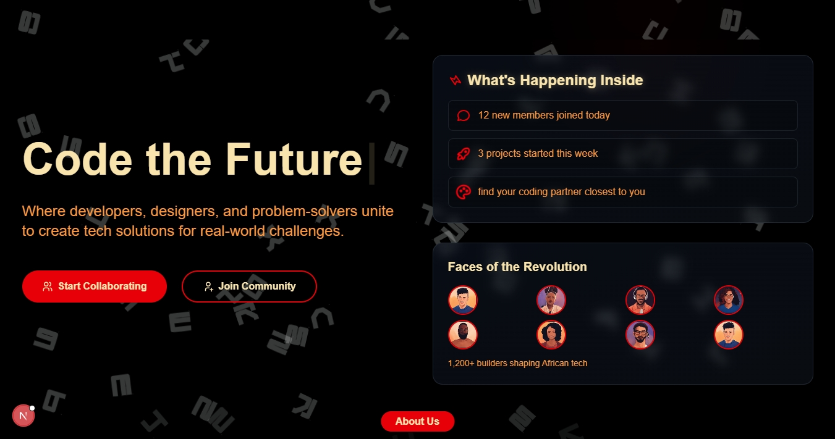

LOGIN PAGE
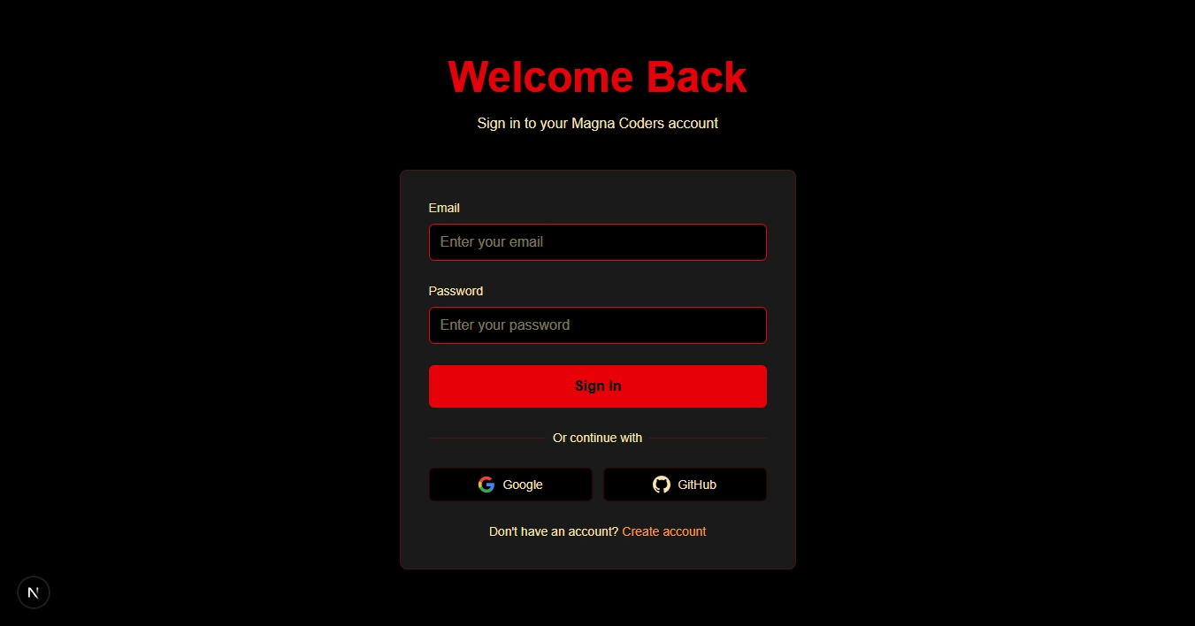

MAIN DASHBOARD
